Newmarket Food & Drink Festival to go ahead in 2021
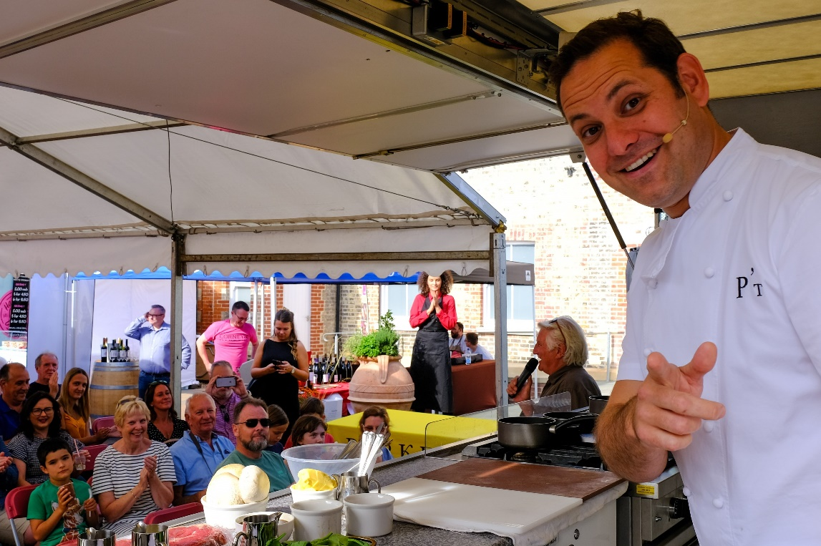
Image: Tristan Welch on main stage at Newmarket Food & Drink Festival 2019
Foodies can pencil in a key date in their calendar as organisers announce one of the region’s largest annual food and drink festivals, the Newmarket Food and Drink Festival, is set to go ahead as a physical event this year.
The hugely popular free Festival, which celebrates the finest food and drink from across East Anglia, attracted over 15,000 visitors in 2019. This year, it is due to take place during the weekend of 11-12 September at a brand-new location, the grounds of The Jockey Club Rooms in the centre of Newmarket. The new location will create more space and organisers hope it will also open the Festival to a larger and more diverse audience. It also offers the chance to view inside one of the world’s most unique sporting venues – limited spaces offered by prior appointment.
Celebrity chefs topping the bill on the main stage this year include chef and TV presenter Rosemary Shrager; Tristan Welch, a regular on BBC 1’s Saturday Kitchen and Chef Director at Parker’s Tavern in Cambridge; and acclaimed master chef Hans Schweitzer, who has cooked for the Queen, presidents, dignitaries and celebrities across the globe. Each chef will demo a range of dishes to teach audiences new skills and offer inspiration in the kitchen.
In addition, the organisers plan to host over 60 artisan Food and Drink producers from across East Anglia and present a weekend packed full of live music, a selection of bars, and family entertainment.
Further details regarding additional celebrity and top regional chefs, music and entertainment, and producers will be announced during the lead up to the Festival.
Festival Chairman, Noel Byrne said: “The Newmarket Food & Drink Festival team are delighted to be back after the event was cancelled last year due to the COVID-19 pandemic. We are even more excited to be hosting the event at a remarkable new location. This is a big step forward for the Festival; hosting the event at The Jockey Club Rooms offers a fantastic opportunity in terms of accessibility and it is a brilliant space to build on the offer to our visitors. It also gives everyone a rare chance to see the grounds of The Jockey Club Rooms.

“We’re very much looking forward to welcoming the thousands of people the Festival attracts to the town for a weekend of fun and entertainment.”
Christopher Ogston, Jockey Club Rooms General Manager, said: “We are delighted to be part of the Newmarket Food & Drink Festival and to be the location for this fantastic culinary event. Noel and the team have been working extremely hard to deliver an event that surpasses previous years. I am sure everyone attending will have a brilliant time watching the chef demonstrations, trying some of the tasty treats on offer, and enjoying the entertainment – which is always superb! – all within the exclusive Jockey Club Rooms grounds.”
The Festival is supported by the Henry Cecil Open Weekend, which takes place the following weekend in and around Newmarket.
Sponsors for the event include Newmarket BID – Love Newmarket, Corney & Barrow, and G’s Fresh, amongst others. The Festival also proudly raises money that goes towards the local charities supported by the Henry Cecil Open Weekend.
The Festival media partner is BBC Radio Cambridgeshire.
For more information about the Festival, visit here.
Keep up to date with the Festival on social media via Facebook: @nktfoodanddrink and Instagram: @nktfoodanddrink
Press contact: Becky Mann | beckymannpr@gmail.com | 07739 131820
-Notes for editors-
COVID-19: The Newmarket Food & Drink Festival will comply with all aspects of Government guidelines that are in force at the time of the Festival to ensure the safety of the public and everyone involved in the event.
Rosemary Shrager is a talented and versatile chef and cookery teacher, who loves talking about food as much as she loves cooking. Her professional career includes working under Pierre Koffmann at the internationally famous Tante Claire restaurant in London and also a period working for Jean-Christophe Novelli. Rosemary began running her own cookery courses at Amhuinnsuidhe Castle and Swinton Park before opening a cookery school in Tunbridge Wells in 2013.
Rosemary endeared herself to the nation when she took part in I'm a Celebrity, Get Me Out Of Here, where she proved she could cook just about anything, anywhere. She regularly appears on popular television series The Real Marigold Hotel, and, in 2017, was a much-loved judge on The Big Family Cooking Showdown. Rosemary regularly demonstrates and teaches her skills at shows and events across the country and abroad.
Tristan Welch started his award-winning culinary career in London as a young chef under Gary Rhodes and went on to join Le Gavroche, working under the guidance of Michel Roux Jr. His career also includes periods working at the avant-garde, triple Michelin starred vegetarian restaurant L’Arpege in Paris; Head Chef at the award-winning five-star Glenapp Castle in Scotland; and Head Chef at Gordon Ramsay’s prestigious Petrus at The Berkeley. Tristan has also run his own restaurant, Launceston Place, which went on to win Best Restaurant in the London TimeOut guide, Most Fashionable London Restaurant, Best In Taste award, plus awards from Tatler and Wine Spectator.
In 2012, Tristan decided to take a two-year sabbatical to devote time to his beloved young family. This was followed by a move to Mustique, where Tristan was Executive Chef at the islands only resort, The Cotton House, a hotspot for royals, VIPs and celebrities. He’s now back in his hometown of Cambridge as Chef Director of Parker’s Tavern at the University Arms Hotel.
Tristan has made numerous TV and radio appearances including BBC2’s Great British Menu, BBC1’s Saturday Kitchen and The One Show.
Master Chef Hans Schweitzer has gained his culinary experience in over 10 countries around the globe and brings his own style and perspective to his cooking. He has cooked for the Queen, presidents, dignitaries and celebrities with menus combining classic techniques with a contemporary approach, showcasing the finest fresh local produce infused with seasonal influences.
Hans’ journey started in the middle east cooking for the late Shar of Persia. He then went on to cook in many different countries gaining a Michelin star in Germany. In 1988, Hans purchased and opened Midsummer House Restaurant in Cambridge and operated for six years. He then took on the challenge of running the kitchens of the famous Sandy Lane Hotel, Barbados in the Caribbean.
In 2008, Hans returned to Cambridge and opened Cotto. During his time at Cotto, the restaurant was listed several times in the top 100 restaurants in the UK.
The Jockey Club Rooms – the spiritual home of British horseracing. With corridors travelled by historical legends, reception rooms enjoyed by Royalty and dining rooms overlooked by equine masterpieces, The Jockey Club Rooms truly is a place like no other. Experience a venue that is built around tradition but embraces innovation. Stay in rooms of pristine elegance that still retain their character and charm. Dine in Georgian splendour while savouring the most modern of culinary delights. At the Jockey Club Rooms, the exclusive becomes accessible and the extraordinary becomes the norm.
Newmarket Open Weekend is a fantastic opportunity to visit the town of Newmarket and go behind the scenes at Horse Racing’s HQ. During the two days, visitors get the chance to see some of the world’s best racehorses at Warren Hill Gallops, tour several of Newmarket’s finest equine sites, go racing at the Rowley Mile racecourse, and visit the yards of some of Newmarket’s leading trainers. Children under 12 years go for FREE. For further information please visit our website at https://www.thehenrycecilopenweekend.co.uk/
Twitter: @NktOpenWeekend | Facebook: https://www.facebook.com/newmarketopenweekend | Instagram: @Nktopenweekend

